HR Attrition Analytics Project Report

About the Dataset
The dataset contains employee information such as age, gender, department, job role, salary hike percentage, work-life balance, job satisfaction, environment satisfaction, business travel, and attrition status. The dataset was analyzed to identify patterns related to employee turnover and workforce management.

Data Dictionary

Column Name | Description
age | Employee age
attrition | Whether the employee left the company or not
business_travel | Employee business travel frequency
daily_rate | Employee daily salary rate
department | Employee department
distance_from_home | Distance between employee home and workplace
education | Employee education level
education_field | Employee education specialization field
employee_count | Total employee count record
employee_number | Unique employee ID number
environment_satisfaction | Employee satisfaction with work environment
gender | Employee gender
hourly_rate | Employee hourly salary rate
job_involvement | Employee involvement in job activities
job_level | Employee job level in organization
job_role | Employee job role/designation
job_satisfaction | Employee job satisfaction rating
marital_status | Employee marital status
monthly_income | Employee monthly income
monthly_rate | Employee monthly salary rate
num_companies_worked | Number of companies employee worked in previously
over18 | Whether employee is above 18 years
over_time | Whether employee works overtime
percent_salary_hike | Percentage increase in employee salary
performance_rating | Employee performance rating
relationship_satisfaction | Employee relationship satisfaction at workplace
standard_hours | Standard working hours
stock_option_level | Employee stock option level
total_working_years | Total years of employee work experience
training_times_last_year | Number of trainings attended last year
work_life_balance | Employee work-life balance rating
years_at_company | Total years employee worked at the company
years_in_currentrole | Years employee spent in current role
years_since_last_promotion | Years since employee last promotion
years_with_curr_manager | Years employee worked with current manager

SQL Business Questions
1. How many total employees are present in the organization?
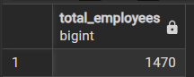

2. How many employees are currently active in the company?

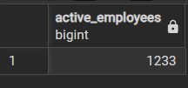

3. How many employees left the organization?

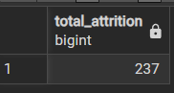

4. What is the overall employee attrition rate?
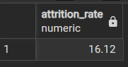

5. What is the average age of employees?
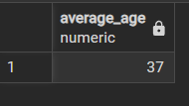

6. Which department has the highest employee attrition?

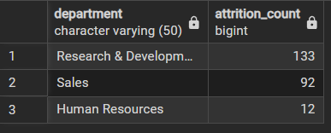

7. How does experience in the current role impact attrition?
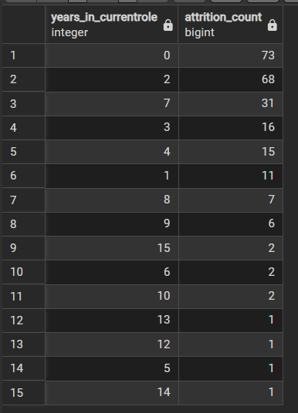

8. Does work-life balance impact employee attrition?

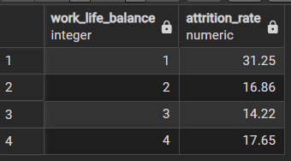

9. Which job roles experience the highest attrition?

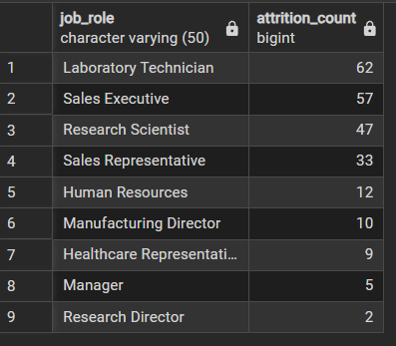

10. Does salary hike percentage influence attrition?
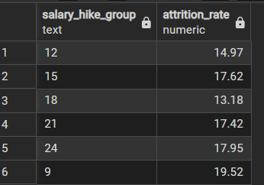

11. Which age groups have the highest attrition rate?
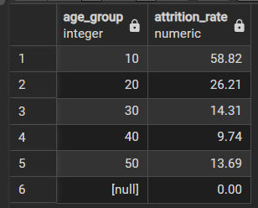

12. Which education background has the highest attrition?

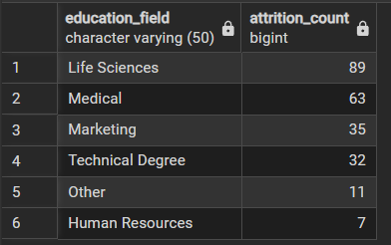

13. Does business travel affect employee attrition?
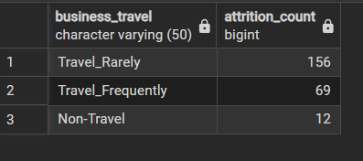

14. How does job satisfaction affect employee attrition?
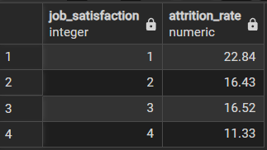

15. Does overtime increase employee attrition?
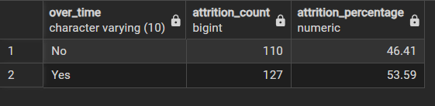

16. Does travel distance from home affect attrition?

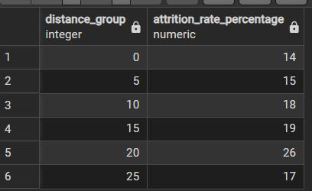

17. Does workplace environment satisfaction influence attrition?

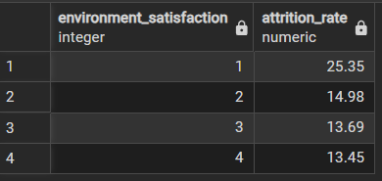

Power BI Dashboard
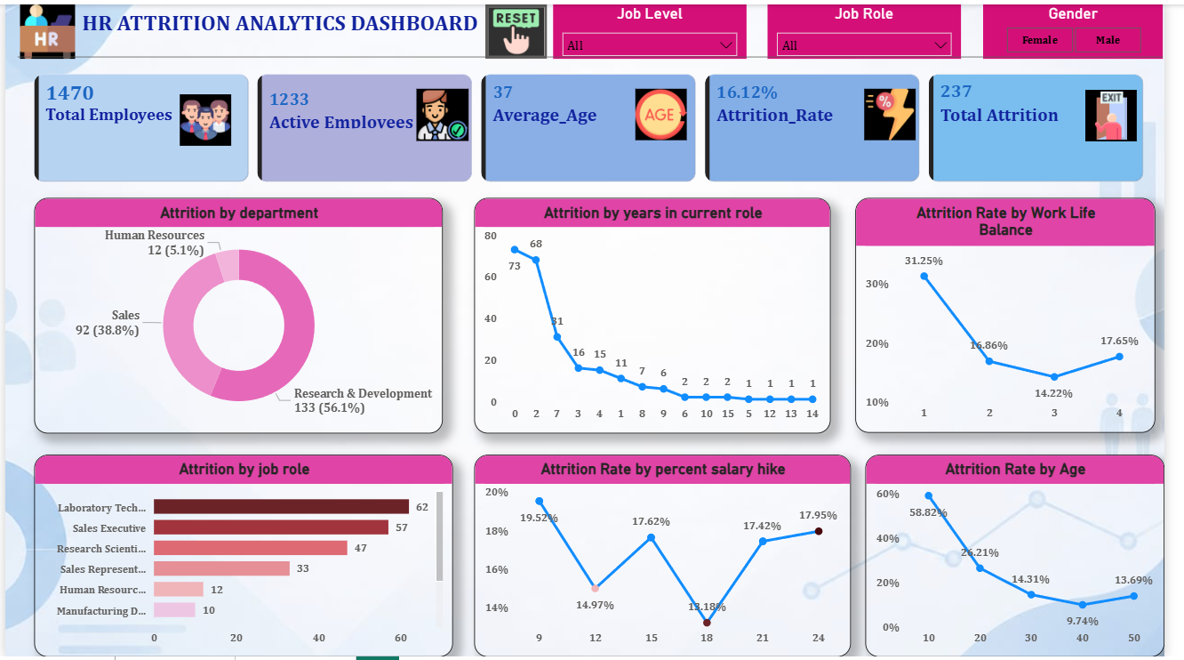
An interactive HR Attrition Analytics dashboard was created in Power BI to visualize employee attrition trends, department-wise analysis, satisfaction analysis, and workforce KPIs

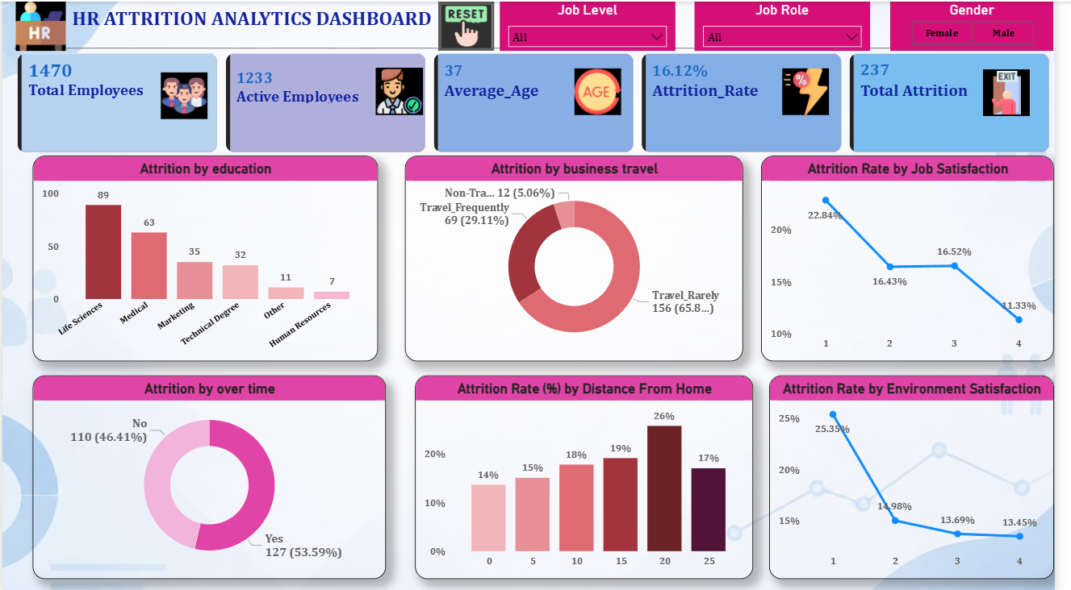

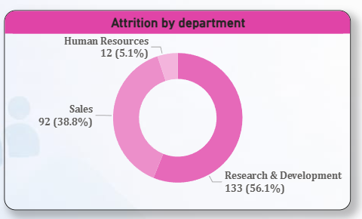
1.

Business Insight

Research & Development department has the highest employee attrition rate.

Business Impact

High attrition in R&D may reduce innovation efficiency and delay project delivery.

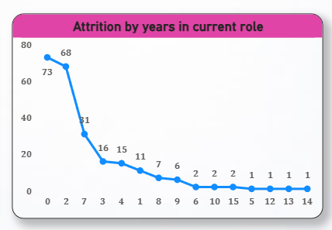
2.

Business Insight

Employees with fewer years in their current role are more likely to leave the company.

Business Impact

Higher early-stage attrition increases hiring and employee training costs.

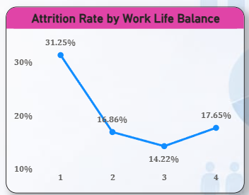
3.

Business Insight

Employees with poor work-life balance show significantly higher attrition rates.

Business Impact

Poor work-life balance can lead to employee burnout and lower productivity.

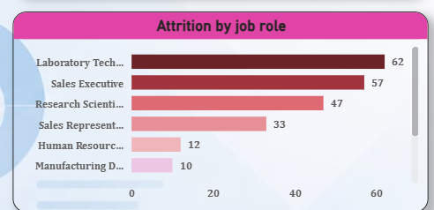
4.

Business Insight

Laboratory Technicians experience the highest attrition among all job roles.

Business Impact

Losing specialized employees can negatively impact operational efficiency.

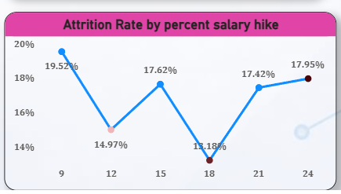
5.

Business Insight

Employees receiving lower salary hikes are more likely to leave the organization.

Business Impact

Inadequate salary growth may reduce employee retention and motivation.
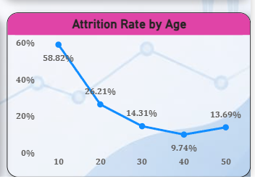
6.

Business Insight

Younger employees show higher attrition compared to older age groups.

Business Impact

High attrition among younger employees may affect long-term workforce stability.

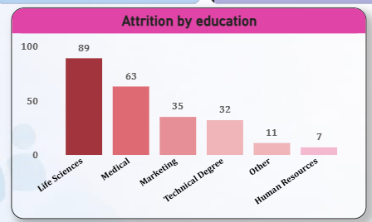
7.

Business Insight

Employees from the Life Sciences education field have the highest attrition count.

Business Impact

Loss of skilled employees may reduce overall business productivity.
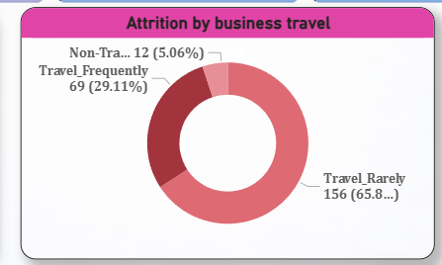
8.

Business Insight

Employees who travel frequently are more likely to leave the company.

Business Impact

Frequent travel requirements may increase employee stress and burnout.
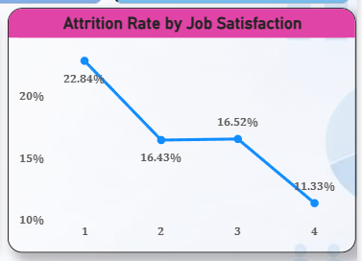
9.

Business Insight

Employees with low job satisfaction have a higher attrition rate.

Business Impact

Low job satisfaction can negatively affect employee performance and retention.
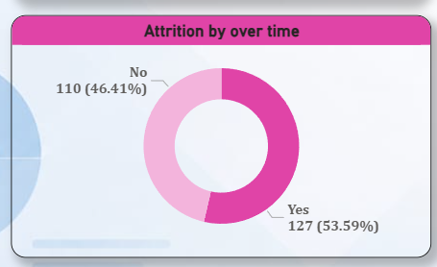
10.

Business Insight

Employees working overtime show higher attrition levels.

Business Impact

Excessive overtime may increase employee fatigue and turnover risk.
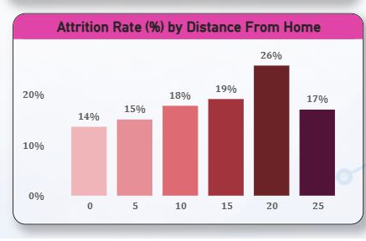
11.

Business Insight

Higher distance from office leads to higher attrition.

Business Impact

Remote work options can help reduce employee turnover.

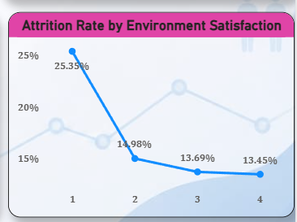
12.

Business Insight

Low environment satisfaction increases attrition rate.

Business Impact

Better workplace environment improves employee retention.

Key Business Insights
1. Research & Development department has the highest employee attrition rate.
2. Employees with fewer years in their current role are more likely to leave the company.
3. Employees with poor work-life balance show significantly higher attrition rates.
4. Laboratory Technicians experience the highest attrition among all job roles.
5. Employees receiving lower salary hikes are more likely to leave the organization.
6. Younger employees show higher attrition compared to older age groups.
7. Employees from the Life Sciences education field have the highest attrition count.
8. Employees who travel frequently are more likely to leave the company.
9. Employees with low job satisfaction have a higher attrition rate.
10. Employees working overtime show higher attrition levels.
11. Higher distance from office leads to higher attrition.
12. Better workplace environment improves employee retention.

Business Recommendations
1. Strengthen employee retention strategies in the R&D department.

2. Enhance career growth and promotion opportunities for new employees.

3. Implement initiatives to improve work-life balance.

4. Develop retention programs for Laboratory Technicians.

5. Offer competitive salary hikes and performance incentives.

6. Increase engagement programs for younger employees.

7. Provide career development support for Life Sciences employees.

8. Minimize frequent travel and provide travel support benefits.

9. Improve job satisfaction through regular employee feedback.

10. Reduce overtime workload to prevent employee burnout.

11. Introduce flexible, hybrid, or remote work policies.

12. Foster a positive and supportive workplace culture.

Conclusion
This project successfully demonstrated the complete Data Analyst workflow including SQL analysis, KPI generation, and Power BI dashboard visualization. The analysis generated valuable HR business insights related to employee attrition, workforce satisfaction, and employee retention strategies. The project demonstrates strong practical knowledge of SQL, Power BI, Excel, and business analytics.

Tools & Technologies Used
- SQL
- Power BI
- Excel Dataset
- DAX Measures
- Data Visualization Techniques.

